COS 470 Image Processing and Computer Vision

2024 Fall

Taylor Brookes

10/15/2024

Assignment 3

Task 1: Feature Detection and Matching (SIFT, ORB)

SIFT:

* <https://citeseerx.ist.psu.edu/document?repid=rep1&type=pdf&doi=cc58efc1f17e202a9c196f9df8afd4005d16042a>
* <https://docs.opencv.org/4.x/da/df5/tutorial_py_sift_intro.html>
* <https://docs.opencv.org/4.x/d7/d60/classcv_1_1SIFT.html>

ORB:

* <https://docs.opencv.org/4.x/d1/d89/tutorial_py_orb.html>
* <https://courses.maine.edu/content/enforced/355524-2510.UMS06-C.0225.1/paper/ORB.pdf>

Q1.1: Keypoint Detection -- use SIFT or ORB to detect keypoints in images. Try to increase its accuracy by fine-tuning.

A1.1:

SIFT Keypoints

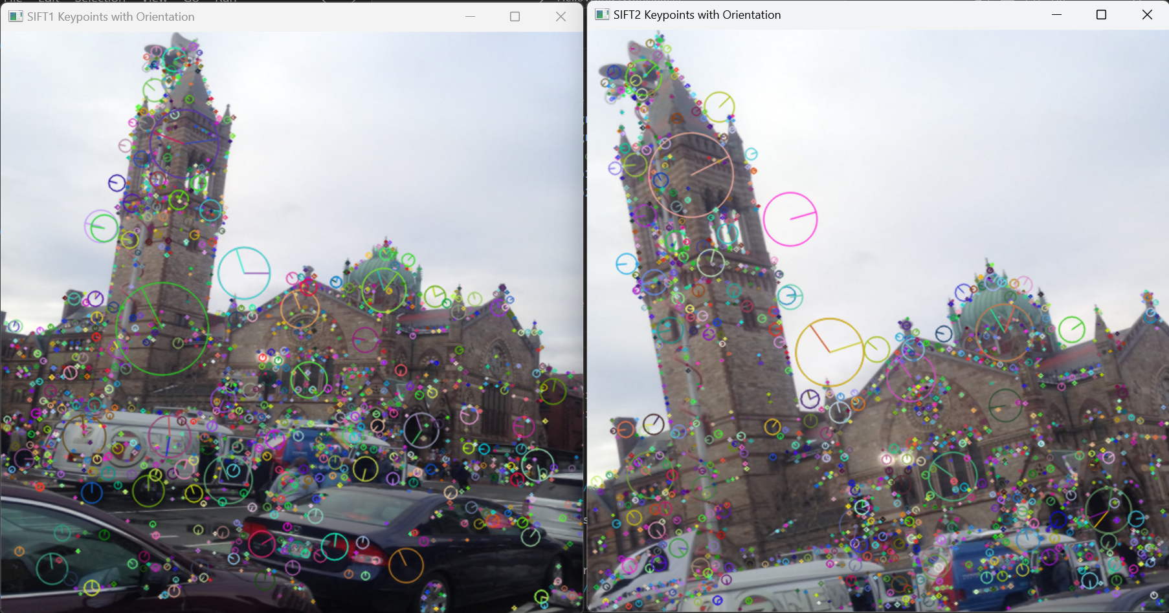

ORB Keypoints

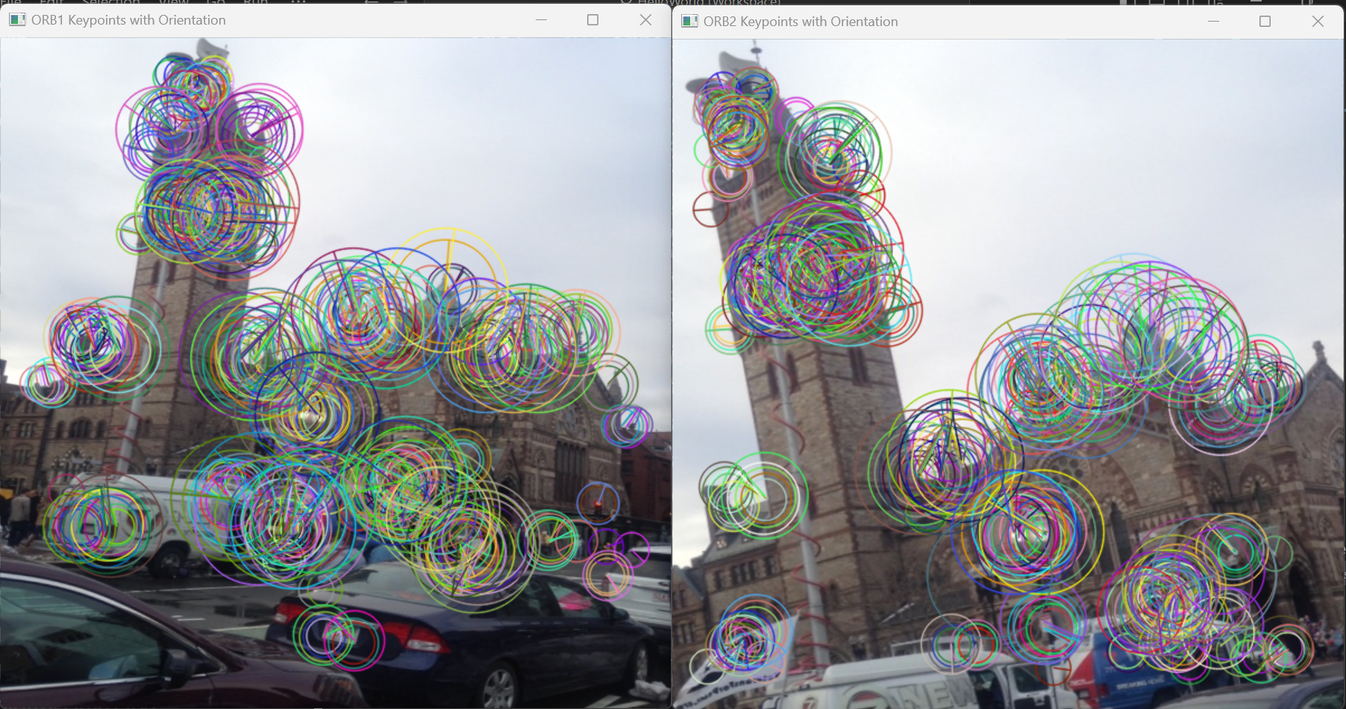

Q1.2 + 1.3: Keypoint Matching -- use FLANN or BFMatcher to match keypoints btw each image pairs. Visualization -- draw lines connecting matched keypoints across image pairs (cv2.drawMatches())

A1.2 + A1.3:

BFMatcher SIFT NNDR 1.0

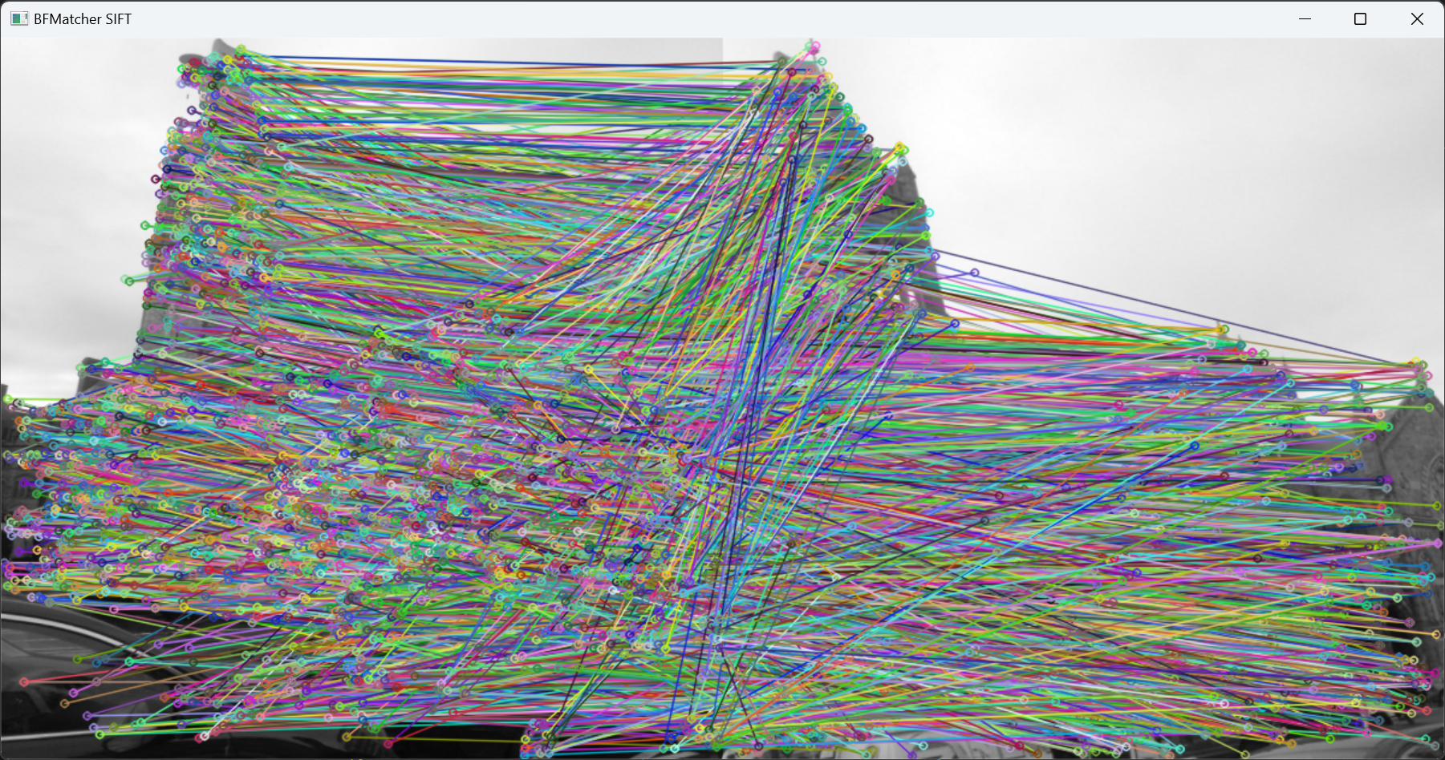

BFMatcher SIFT NNDR 0.8

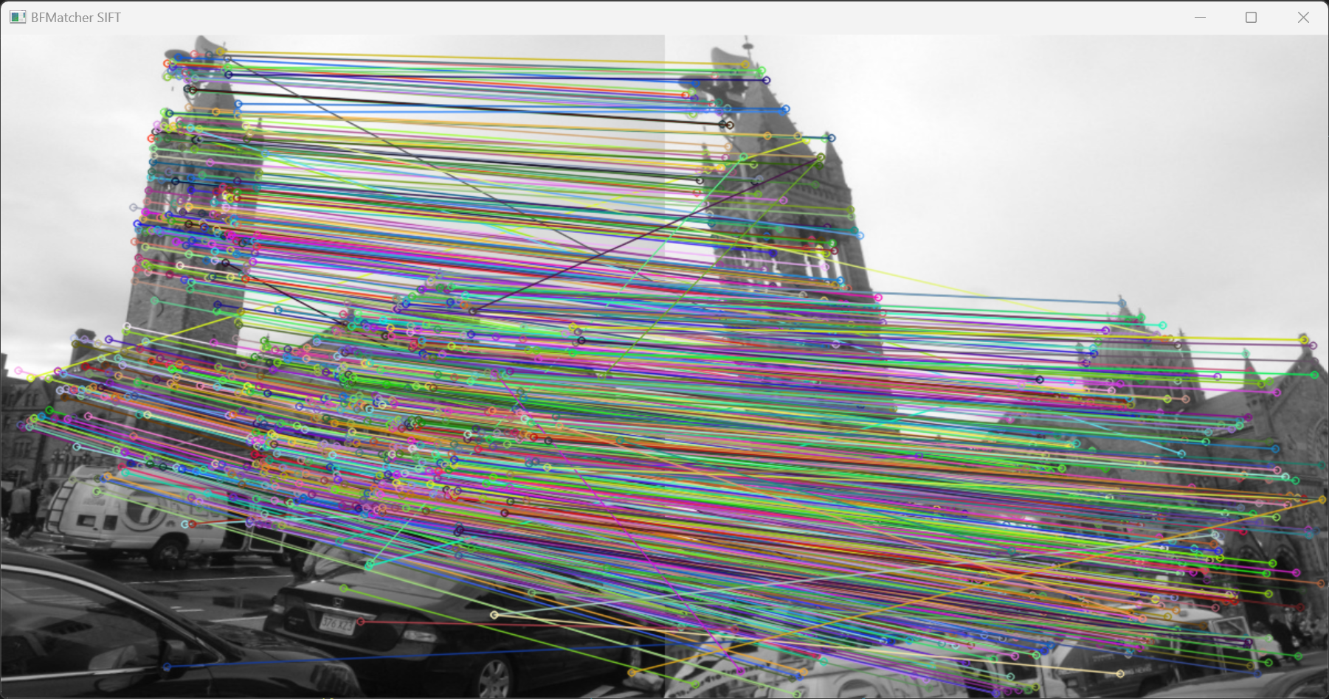

BFMatcher SIFT NNDR 0.8 Tuned

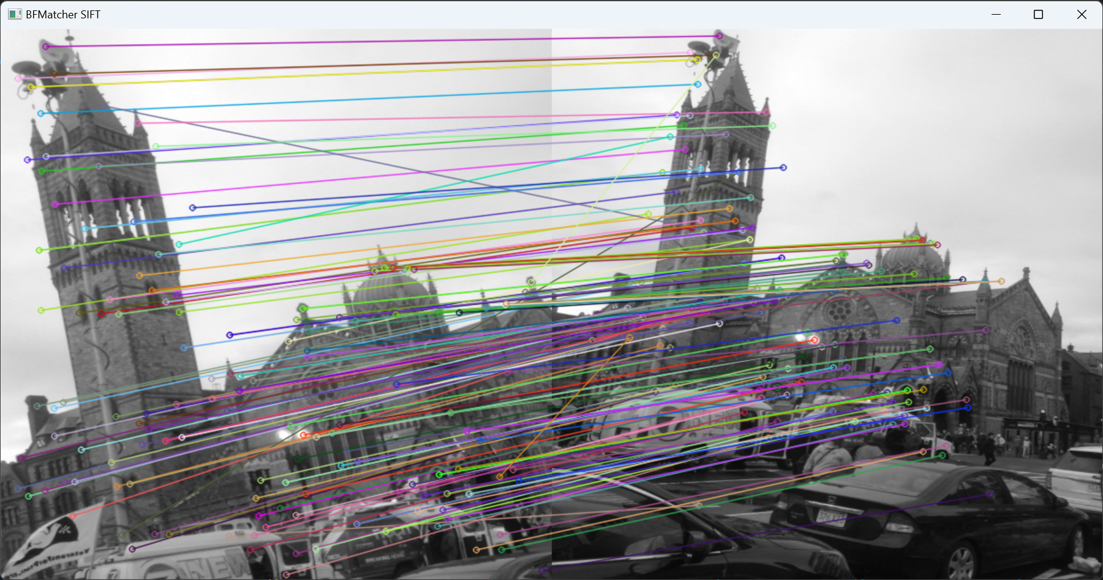

BFMatcher ORB NNDR 0.8

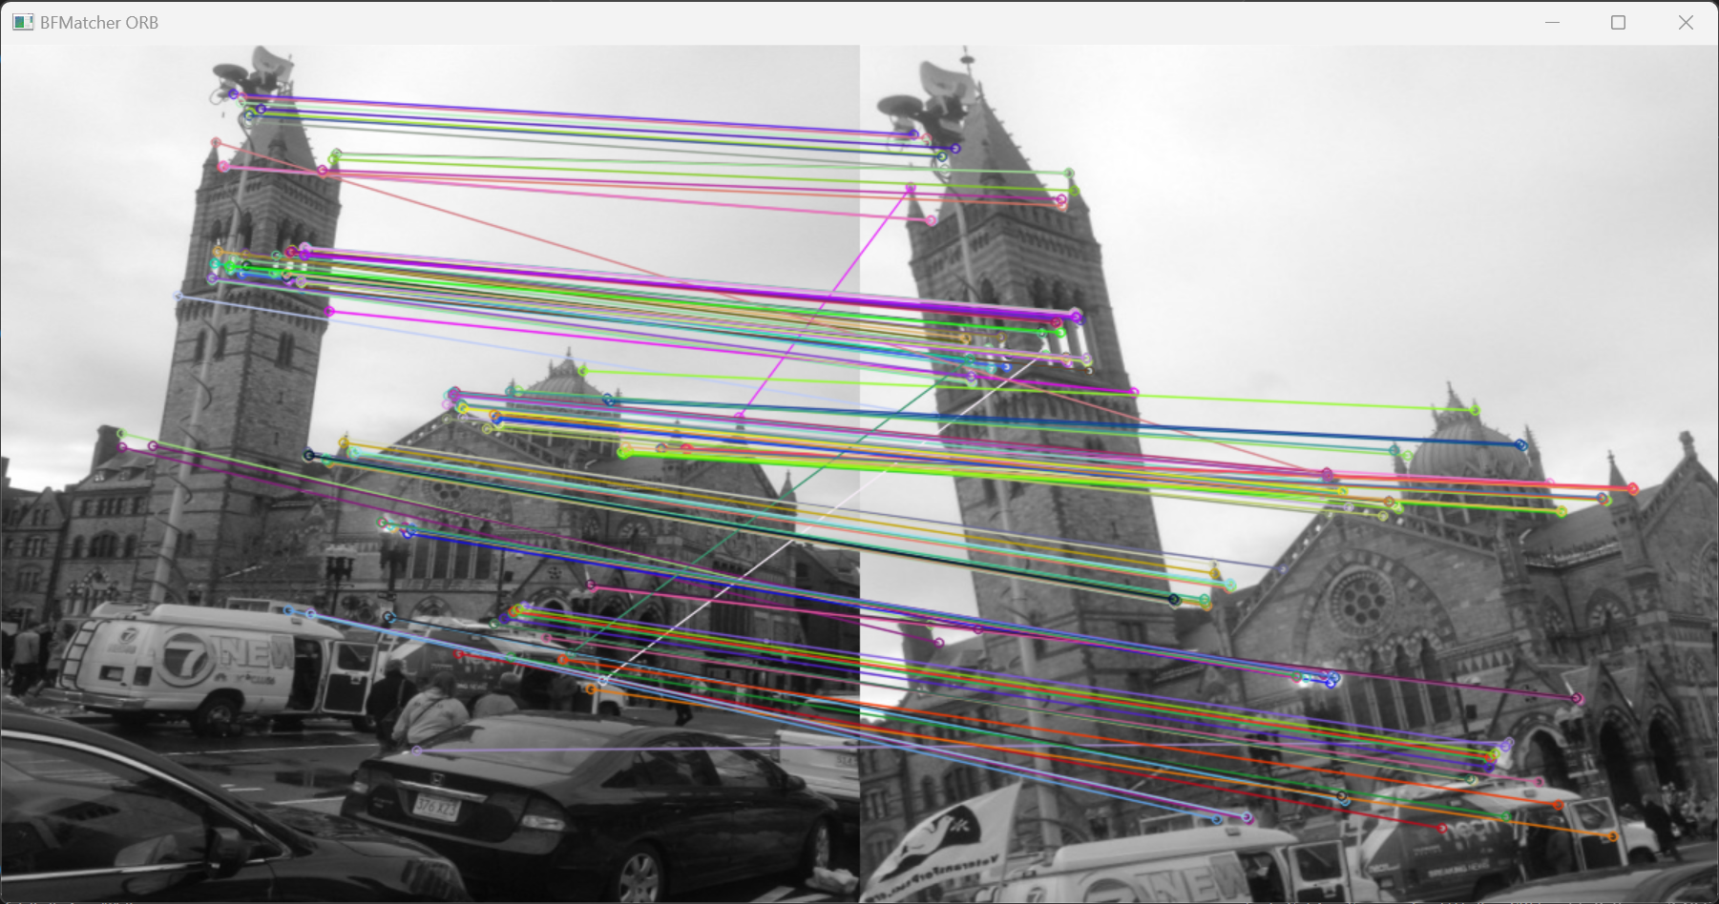

FLANN SIFT NNDR 0.8

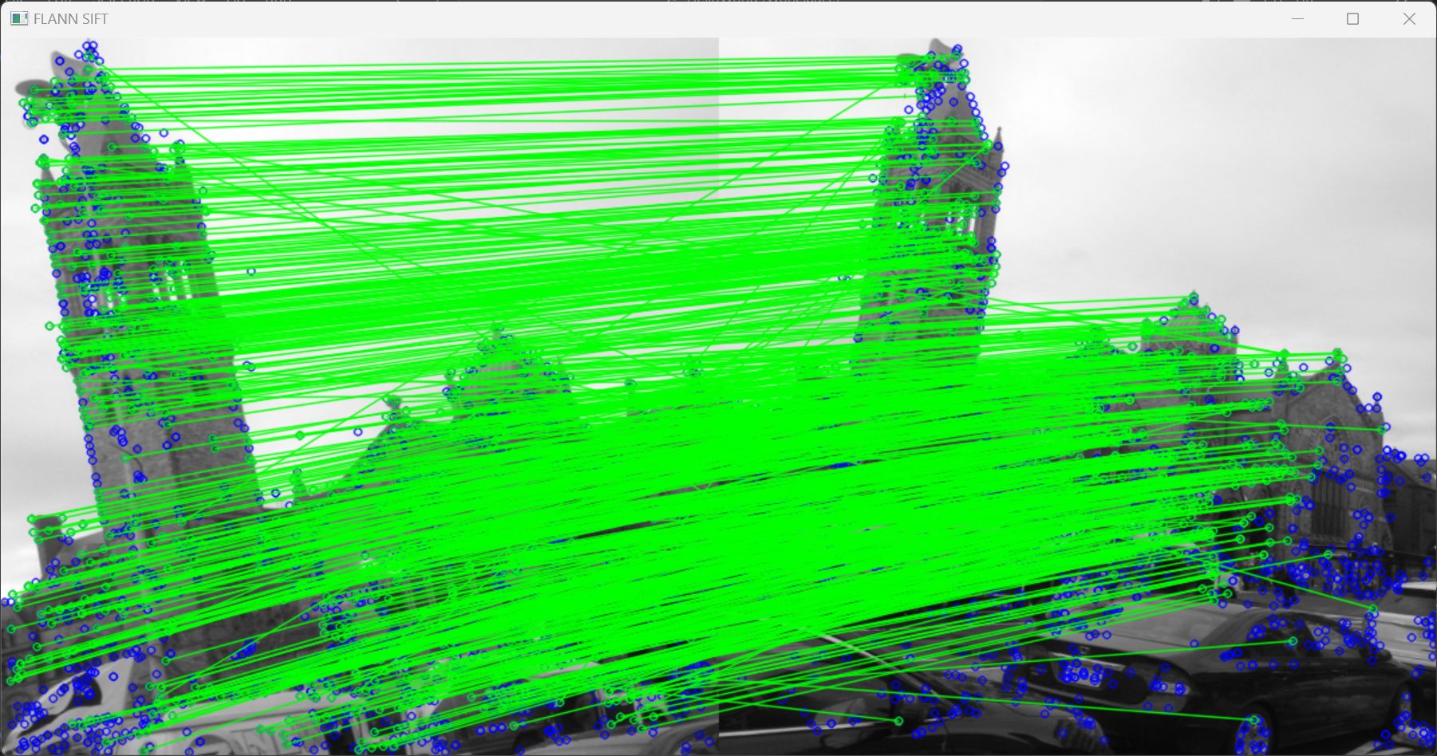

FLANN ORB NNDR 0.8

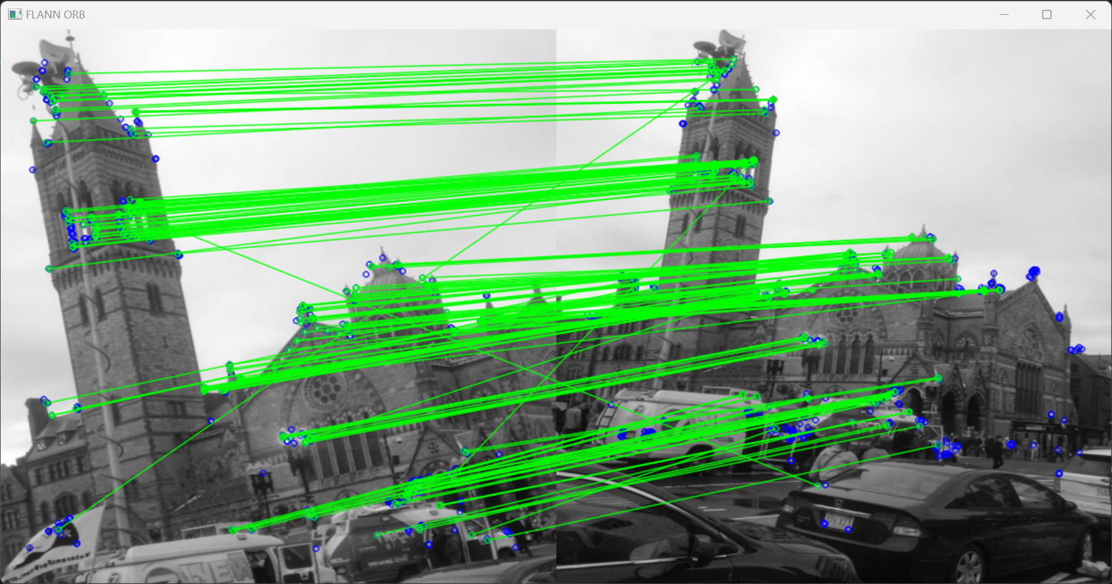

Q1.4: Evaluation of Matches -- report# of good and bad matches, determine accuracy for each image pair. describe how parameter tuning affects the results. Match = good if NNDR < preset threshold (0.8). NNDR compares distance to nearest neighbour with that of the second nearest neighbour, filtering out weaker matches

A1.4:

| image/config | matches | good | bad | accuracy |
| --- | --- | --- | --- | --- |
| boston SIFT BFMatcher NNDR 0.8 | 3,148 | 1,168 | 1,980 | 37.10% |
| boston SIFT FLANN NNDR 0.8 | 3,148 | 1,186 | 1,962 | 37.67% |
| boston SIFT BFMatcher NNDR 0.8 swapped | 2,280 | 1,150 | 1,130 | 50.44% |
| boston SIFT FLANN NNDR 0.8 swapped | 2,280 | 1,155 | 1,125 | 50.66% |
| boston ORB BFMatcher NNDR 0.8 500 | 500 | 230 | 270 | 46.00% |
| boston ORB FLANN NNDR 0.8 500 | 500 | 246 | 254 | 49.20% |
| boston ORB BFMatcher NNDR 0.8 max | 9,318 | 2,776 | 6,542 | 29.79% |
| boston ORB FLANN NNDR 0.8 max | 9,318 | 2,863 | 6,455 | 30.73% |
| boston ORB BFMatcher NNDR 0.8 swapped 500 | 500 | 240 | 260 | 48.00% |
| boston ORB FLANN NNDR 0.8 swapped 500 | 500 | 243 | 257 | 48.60% |
| boston ORB BFMatcher NNDR 0.8 swapped max | 5,427 | 2,581 | 2,846 | 47.56% |
| boston ORB FLANN NNDR 0.8 swapped max | 5,427 | 2,615 | 2,812 | 48.19% |
| boston SIFT BFMatcher NNDR 0.8 TUNED | 377 | 235 | 142 | 62.33% |
| boston SIFT FLANN NNDR 0.8 TUNED | 377 | 235 | 142 | 62.33% |
| boston ORB BFMatcher NNDR 0.8 TUNED | 500 | 258 | 242 | 51.60% |
| boston ORB FLANN NNDR 0.8 TUNED | 500 | 261 | 239 | 52.20% |
| castle SIFT BFMatcher NNDR 0.8 | 34,718 | 10,469 | 24,249 | 30.15% |
| castle SIFT FLANN NNDR 0.8 swapped | 29,480 | 10,274 | 19,206 | 34.85% |
| castle ORB BFMatcher NNDR 0.8 500 | 500 | 269 | 231 | 53.80% |
| castle ORB FLANN NNDR 0.8 max | 127,075 | 51,792 | 75,283 | 40.76% |
| castle SIFT BFMatcher NNDR 0.8 TUNED | 3,206 | 2,059 | 1,147 | 64.22% |
| rushmore SIFT BFMatcher NNDR 0.8 | 17,169 | 1,180 | 15,989 | 6.87% |
| rushmore SIFT FLANN NNDR 0.8 swapped | 30,444 | 1,640 | 28,804 | 5.39% |
| rushmore ORB BFMatcher NNDR 0.8 500 | 500 | 30 | 470 | 6.00% |
| rushmore ORB FLANN NNDR 0.8 max | 48,599 | 4,054 | 44,545 | 8.34% |
| rushmore SIFT BFMatcher NNDR 0.8 TUNED | 4,337 | 876 | 2,461 | 20.20% |
| dame SIFT BFMatcher NNDR 0.8 | 24,548 | 2,557 | 21,991 | 10.42% |
| dame SIFT FLANN NNDR 0.8 swapped | 20,376 | 2,582 | 17,794 | 12.67% |
| dame ORB BFMatcher NNDR 0.8 500 | 500 | 19 | 481 | 3.80% |
| dame ORB FLANN NNDR 0.8 max | 86,458 | 8,946 | 77,512 | 10.35% |
| dame SIFT BFMatcher NNDR 0.8 sigma=5.0 | 2,613 | 698 | 1,915 | 26.71% |

Tuning:

| category | total | good | bad | percent |
| --- | --- | --- | --- | --- |
| boston ORB BFMatcher original NNDR 0.8 | 500 | 230 | 270 | 46.00% |
| swapped | 500 | 240 | 260 | 48.00% |
| swapped nfeatures=max (default 500) | 5,427 | 2,581 | 2,846 | 47.56% |
| swapped scaleFactor=2 (default 1.2) | 441 | 194 | 247 | 43.99% |
| swapped scaleFactor=1.05 | 500 | 125 | 375 | 25.00% |
| swapped nlevels=4 (default 8) | 500 | 213 | 287 | 42.60% |
| swapped nlevels=16 | 454 | 219 | 235 | 48.25% |
| swapped nlevels=32 | 432 | 216 | 216 | 50.00% |
| swapped edgeThreshold=15 (default 31) | 500 | 258 | 242 | 51.60% |
| swapped edgeThreshold=63 | 466 | 190 | 276 | 40.77% |
| swapped firstLevel=1 (default 0) | 500 | 243 | 257 | 48.60% |
| swapped firstLevel=2 (default 0) | 500 | 240 | 260 | 48.00% |
| swapped WPA_K=3, cv2.NORM_HAMMING2 (default 2, HAMMING | 500 | 226 | 274 | 45.20% |
| swapped WPA_K=4, HAMMING2 | 500 | 223 | 277 | 44.60% |
| swapped cv2.ORB_FAST_SCORE (default cv2.ORB_HARRIS_SCORE) | 507 | 240 | 267 | 47.34% |
| swapped patchSize=15 (default 31) | 500 | 157 | 343 | 31.40% |
| swapped patchSize=63 | 500 | 243 | 257 | 48.60% |
| swapped edgeThreshold=15, patchSize=63 | 500 | 239 | 261 | 47.80% |
| swapped fastThreshold=10 (default 20) | 500 | 240 | 260 | 48.00% |
| swapped fastThreshold=40 | 495 | 239 | 256 | 48.28% |

| category | total | good | bad | percent |
| --- | --- | --- | --- | --- |
| boston ORB FLANN original NNDR 0.8 | 500 | 243 | 257 | 48.60% |
| … mostly the same, all below is also swapped |  |  |  |  |
| swapped edgeThreshold=15 (default 31) | 500 | 261 | 239 | 52.20% |
| index_params table_number=12 | 500 | 242 | 258 | 48.40% |
| index_params key_size=20 | 500 | 186 | 314 | 37.20% |
| index_params multi_probe_level=2 | 500 | 241 | 259 | 48.20% |
| index_params ^ 3 above combined | 500 | 256 | 244 | 51.20% |
| search_params checks=25 (default 50?) | 500 | 243 | 257 | 48.60% |
| search_params checks=100 | 500 | 243 | 257 | 48.60% |

| category | total | good | bad | percent |
| --- | --- | --- | --- | --- |
| boston SIFT BFMatcher original NNDR 0.8 | 3,148 | 1,168 | 1,980 | 37.10% |
| swapped | 2,280 | 1,150 | 1,130 | 50.44% |
| swapped nfeatures=500 (default 0) | 500 | 241 | 259 | 48.20% |
| swapped nfeatures=100,000 (same as 0) | 2,280 | 1,150 | 1,130 | 50.44% |
| swapped nOctaveLayers=2 (default 3) | 1,934 | 1,032 | 902 | 53.36% |
| swapped nOctaveLayers=4 | 2,498 | 1,286 | 1,212 | 51.48% |
| swapped contrastThreshold=0.02 (default 0.04) | 4,029 | 2,012 | 2,017 | 49.94% |
| swapped contrastThreshold=0.06 | 1,220 | 604 | 616 | 49.51% |
| swapped edgeThreshold=5 (default 10) | 1,750 | 886 | 864 | 50.63% |
| swapped edgeThreshold=20 | 2,554 | 1,295 | 1,259 | 50.70% |
| swapped sigma=1.2 (default 1.6) | 3,034 | 1,347 | 1,687 | 44.40% |
| swapped sigma=2.0 | 1,731 | 931 | 800 | 53.78% |
| swapped enable_precise_upscale=True (default false) | 2,245 | 1,101 | 1,144 | 49.04% |
| swapped nOctaveLayers=2, edgeThreshold=5 | 1,501 | 803 | 698 | 53.50% |
| swapped nOctaveLayers=2, edgeThreshold=20 | 2,186 | 1,159 | 1,027 | 53.02% |
| swapped nOctaveLayers=2, sigma=2.0 | 1,387 | 758 | 629 | 54.65% |
| swapped edgeThreshold=5, sigma=2.0 | 1,319 | 710 | 609 | 53.83% |
| swapped edgeThreshold=20, sigma=2.0 | 1,957 | 1,060 | 897 | 54.16% |
| swapped sigma=3.0 | 841 | 512 | 329 | 60.88% |
| swapped sigma=5.0 | 377 | 235 | 142 | 62.33% |

| category | total | good | bad | percent |
| --- | --- | --- | --- | --- |
| boston SIFT FLANN original NNDR 0.8 | 3,148 | 1,186 | 1,962 | 37.67% |
| swapped | 2,280 | 1,155 | 1,125 | 50.66% |
| … all almost the same, all below is also swapped |  |  |  |  |
| swapped sigma=5.0 | 377 | 235 | 142 | 62.33% |
| index_params trees=2 (default 5) | 2,280 | 1,156 | 1,124 | 50.70% |
| index_params trees=10 | 2,280 | 1,152 | 1,128 | 50.53% |
| search_params checks=25 (default 50?) | 2,280 | 1,161 | 1,119 | 50.92% |
| search_params checks=100 | 2,280 | 1.152 | 1,128 | 50.53% |

I was getting an error on FLANN ORB: “ValueError: not enough values to unpack (expected 2, got 1)”, so I googled it and found out that sometimes there aren't matches for the pairs, so I implemented the try-catch block solution found here:

<https://stackoverflow.com/questions/55612455/when-receiving-valueerror-not-enough-values-to-unpack-expected-2-got-1-ho>

NOTES:

max → nfeatures=0

500 → parameter not added, default value is 500

swapped → img1 (query) = Boston1.jpeg, img2 (train) = Boston.jpeg

TUNED → messed with each parameter one by one to get as high as possible

Parameter tuning refines the criteria for matches, EX: “swapped sigma=2.0” means the images have been processed in reverse order (EX: Boston1 as query and Boston as training), and that the Gaussian Filter’s sigma has been changed from the default 1.6 to 2.0. Sigma in a Gaussian Filter changes the standard deviation of the filter, which in turn defines the amount of blurring that takes place in the preprocessing of the image. A larger sigma means the image is blurred more.

Taks2: Application of Feature Matching for Depth Estimation

Q2: explain the concepts, methods, theory, and step-by-step of how feature matching can be used for depth information and estimation from images.

A2:

#### Camera Calibration

Cameras create distortion, with the two main kinds being Radial Distortion and Tangential Distortion. Radial distortion curves an image around the corners of the picture, while Tangential distortion has closer objects appear larger than they actually are.

There are intrinsic and extrinsic parameters of the camera. Intrinsic parameters include focal length and optical centers, while extrinsic parameters include rotation and translation vectors which occur due to 3D space being compressed into 2D.

The important input data needed for calibration of the camera is the set of 3D real world points and the corresponding 2D coordinates of these points in the image. These require the X,Y,Z coordinates of a set of images to calibrate the camera. For simplicity, the article keeps the chess board on a constant Z axis and while moving the camera along the Z axis, which only requires knowing the values of X,Y now. To calibrate the camera, we find the corners of the images in the set being used, in this case of chessboards, with cv2.findChessboardCorners(). 3D points are object points and 2D points are image points. We first create the calibration for the camera with cv2.calibrateCamera() with the object and image points as inputs. For a new input image that we would like to undistort, we use cv2.getOptimalNewCameraMatrix() to create a matrix based on a free scaling parameter, and it also creates a ROI (region of interest) for the input image. We then use cv2.undistort() and crop the undistorted image by the ROI. To find how close the new undistorted image is to what it should be, we use cv2.projectPoints(), calculate error with cv2.norm, and then find the mean. A high error score is worse than a low error score.

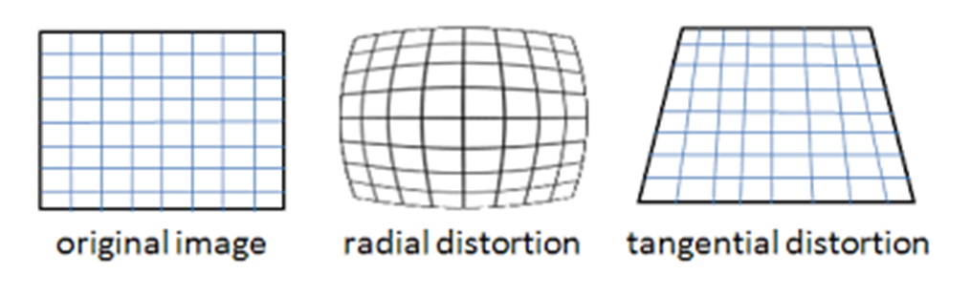

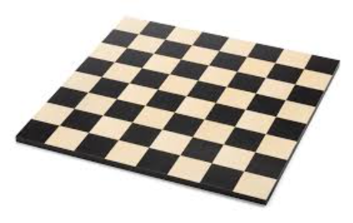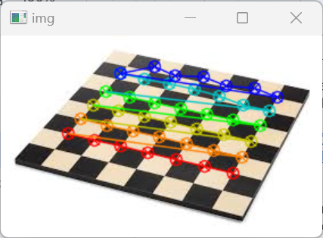

#### Pose Estimation

We now can calculate how a new image taken from the same camera is oriented in space. To do this, we create lines in space for the representation of each axis (X,Y,Z) using cv2.line(). We then find the interior grid of the chessboard input image, use cv2.solvePnPRansac() to calculate rotation and translation, and draw the projection of the axis points with a 21 line generateImage() function. These can either be lines in 3D space or a cube in 3D space.

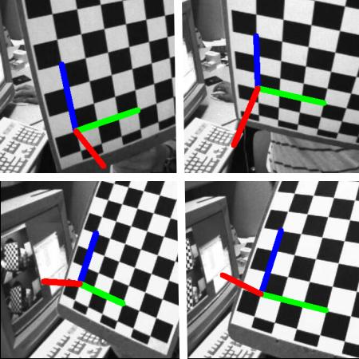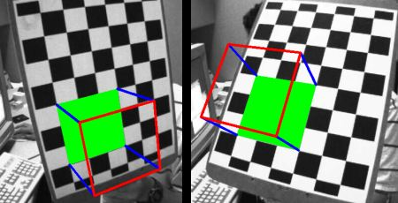

#### Epipolar Geometry

Depth information is able to be found through the use of more than one image taken of one subject at a different perspective. Stereo vision is the use of 2 images, and epipolar geometry is the geometry of stereo vision. We use the two images to triangulate 2D image points into 3D object points. The projection of the X point from the line OX onto the right plane forms line L’ with points X’ along line OX, which all the X’ points from the right plane translate to the single X point on the left plane. Line L’ is called an epiline. The epipolar constraint is the location of X along line L’, which can be any of the values of X’ until the right one is found in the 3D space. The epipolar plane is the plane between O, X, and O’, which spans 180deg of O and 180deg of O’ along the respective epilines. E is the point on the epiline that is the location of O’ (the camera center of the right plane), called an epipole, which may sometimes be located outside the image, meaning one camera may not be able to see the other. The location of the epipole is found through the use of many epilines and the location of their intersection points. To find these, we need the Essential Matrix (translation and rotation) and the Fundamental Matrix (the essential matrix with the addition of information about the intrinsics of both cameras used to relate the two cameras in pixel coordinates, EX: focal length and optical centers). The fundamental matrix maps a point from one image (plane) to the epiline of another image (plane), and we need at least 8 of these points, calculated by matching points from both images. To find these matches, we use SIFT FLANN with the ratio test to find good matches between the two images, then find the fundamental matrix with cv2.findFundamentalMatrix(), select only inlier points, then find the epilines and draw them on both images. The point at which the epilines converge is the epipole of the other image.

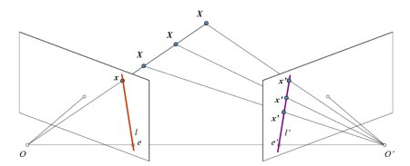

planes, epilines, epipoles

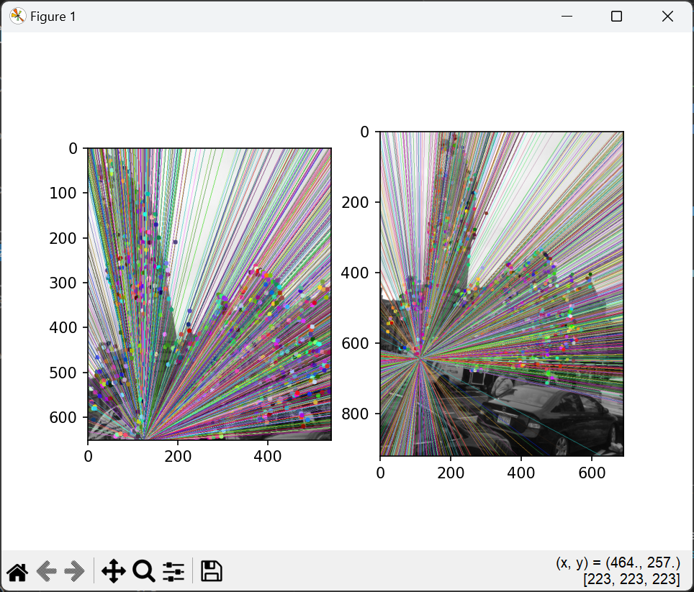

epiline generation from the provided code

#### Depth Map from Stereo Images

The depth of a point in a scene is inversely proportional to the difference in distance of corresponding image points (2D) and their camera centers (epipoles). This can be used to find the depth of all pixels in an image. When matches are found, we calculate the disparity (disparity map). Noise can be created in this new map, and reduced by adjusting parameters with getters and setters.

Disparity = x - x’ = Bf / Z

x = distance between point in image plane corresponding to O

x’ = same, corresponding to O’

B = distance between the two camera (known, epipoles)

f = focal length of camera (known)

Z = length from O / O’ to X along one axis

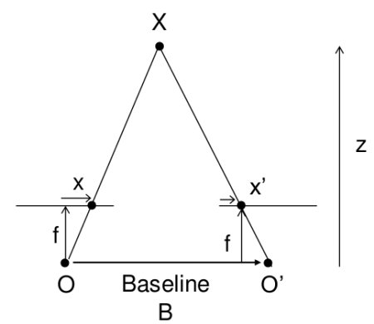

#### How Feature Mapping is used for Depth Estimation

Feature mapping can be used for depth estimation by creating a depth map from a set of stereo images. The quality of the feature map is dependent upon the depths in the images and the amount of noise present in the images.

1. read 2 images in: a left and a right image of the same subject but at different perspectives
2. create a stereo object
3. calculate a disparity map of the image

import numpy as np

import cv2 as cv

from matplotlib import pyplot as plt

imgL = cv.imread('Boston1.jpeg', cv.IMREAD_GRAYSCALE)

imgL = cv.resize(imgL, (600,600))

imgR = cv.imread('Boston.jpeg', cv.IMREAD_GRAYSCALE)

imgR = cv.resize(imgR, (600,600))

stereo = cv.StereoBM.create(numDisparities=16, blockSize=15)

disparity = stereo.compute(imgL,imgR)

plt.imshow(disparity,'gray')

plt.show()

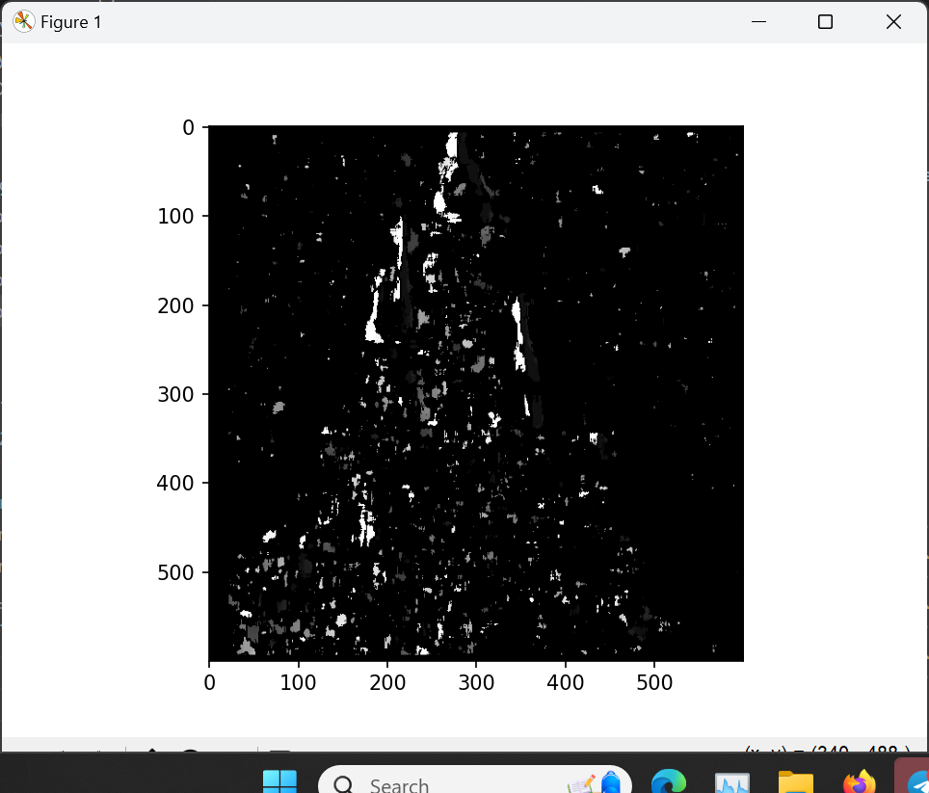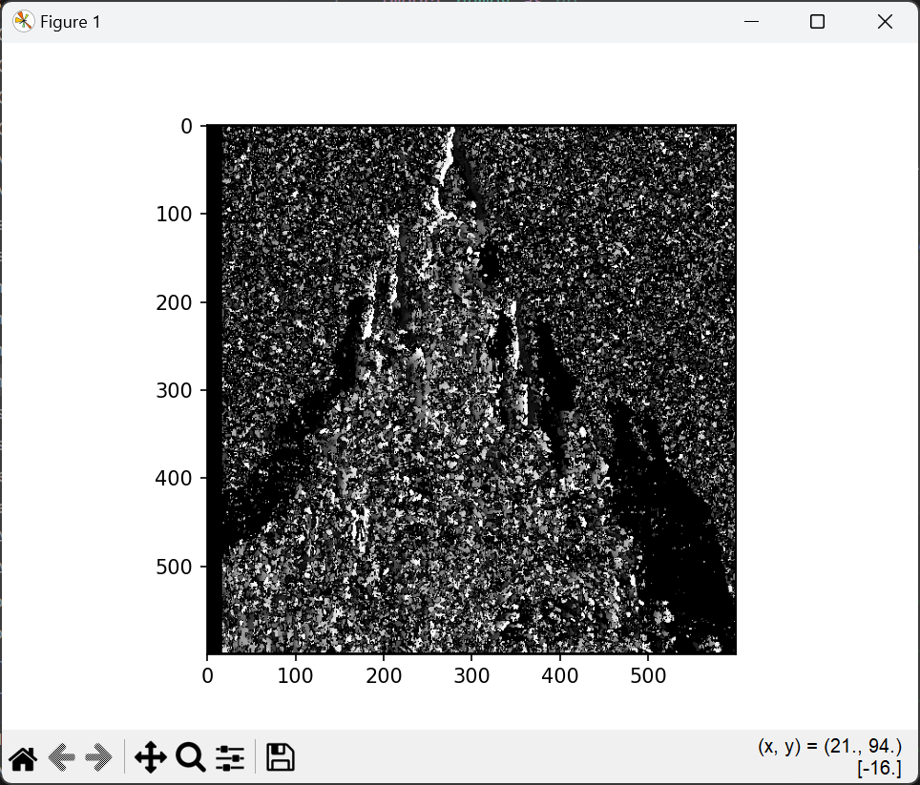

The above image is a disparity map between Castle.jpg and Castle1.jpg. The outline of the castle is somewhat visible, with different shades indicating different depths. Left is blockSize=15, right is blockSize = 5.

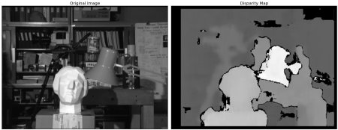

the provided disparity map from the article